WEEK 8
Write a C program to simulate the following contiguous
memory allocation techniques.
a) Worst-fit
b) Best-fit
c) First-fit
#include <stdio.h>

void firstFit(int blockSize[], int m, int processSize[], int n)
{
int allocation[10];
int tempBlock[10];
int i, j;

for(i = 0; i < m; i++)
{
tempBlock[i] = blockSize[i];
}

for(i = 0; i < n; i++)
{
allocation[i] = -1;
}

for(i = 0; i < n; i++)
{
for(j = 0; j < m; j++)
{
if(tempBlock[j] >= processSize[i])
{
allocation[i] = j;

tempBlock[j] -= processSize[i];

break;
}
}
}

printf("\n--- FIRST FIT ALLOCATION ---\n");

printf("Process No\tProcess Size\tBlock No\n");

for(i = 0; i < n; i++)
{
printf("%d\t\t%d\t\t", i + 1, processSize[i]);

if(allocation[i] != -1)
{
printf("%d\n", allocation[i] + 1);
}
else
{
printf("Not Allocated\n");
}
}
}

void bestFit(int blockSize[], int m, int processSize[], int n)
{
int allocation[10];
int tempBlock[10];
int i, j, bestIdx;

for(i = 0; i < m; i++)
{
tempBlock[i] = blockSize[i];
}

for(i = 0; i < n; i++)
{
allocation[i] = -1;
}

for(i = 0; i < n; i++)
{
bestIdx = -1;

for(j = 0; j < m; j++)
{
if(tempBlock[j] >= processSize[i])
{
if(bestIdx == -1 || tempBlock[j] < tempBlock[bestIdx])
{
bestIdx = j;
}
}
}

if(bestIdx != -1)
{
allocation[i] = bestIdx;

tempBlock[bestIdx] -= processSize[i];
}
}

printf("\n--- BEST FIT ALLOCATION ---\n");

printf("Process No\tProcess Size\tBlock No\n");

for(i = 0; i < n; i++)
{
printf("%d\t\t%d\t\t", i + 1, processSize[i]);

if(allocation[i] != -1)
{
printf("%d\n", allocation[i] + 1);
}
else
{
printf("Not Allocated\n");
}
}
}

void worstFit(int blockSize[], int m, int processSize[], int n)
{
int allocation[10];
int tempBlock[10];
int i, j, worstIdx;

for(i = 0; i < m; i++)
{
tempBlock[i] = blockSize[i];
}

for(i = 0; i < n; i++)
{
allocation[i] = -1;
}

for(i = 0; i < n; i++)
{
worstIdx = -1;

for(j = 0; j < m; j++)
{
if(tempBlock[j] >= processSize[i])
{
if(worstIdx == -1 || tempBlock[j] > tempBlock[worstIdx])
{
worstIdx = j;
}
}
}

if(worstIdx != -1)
{
allocation[i] = worstIdx;

tempBlock[worstIdx] -= processSize[i];
}
}

printf("\n--- WORST FIT ALLOCATION ---\n");

printf("Process No\tProcess Size\tBlock No\n");

for(i = 0; i < n; i++)
{
printf("%d\t\t%d\t\t", i + 1, processSize[i]);

if(allocation[i] != -1)
{
printf("%d\n", allocation[i] + 1);
}
else
{
printf("Not Allocated\n");
}
}
}

int main()
{
int blockSize[10], processSize[10];
int m, n, i;

printf("Enter number of memory blocks: ");
scanf("%d", &m);

printf("Enter size of each memory block:\n");

for(i = 0; i < m; i++)
{
scanf("%d", &blockSize[i]);
}

printf("Enter number of processes: ");
scanf("%d", &n);

printf("Enter size of each process:\n");

for(i = 0; i < n; i++)
{
scanf("%d", &processSize[i]);
}

firstFit(blockSize, m, processSize, n);

bestFit(blockSize, m, processSize, n);

worstFit(blockSize, m, processSize, n);

return 0;
}

Output:

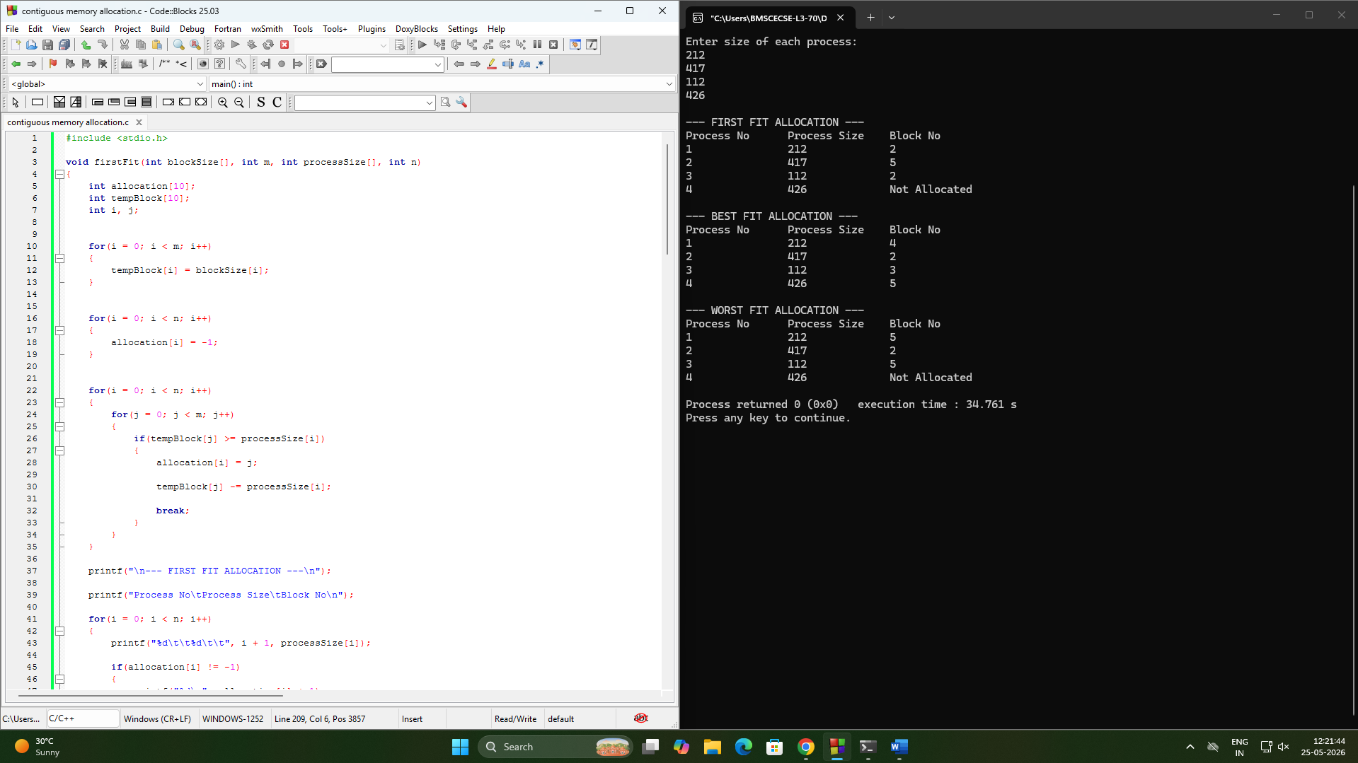

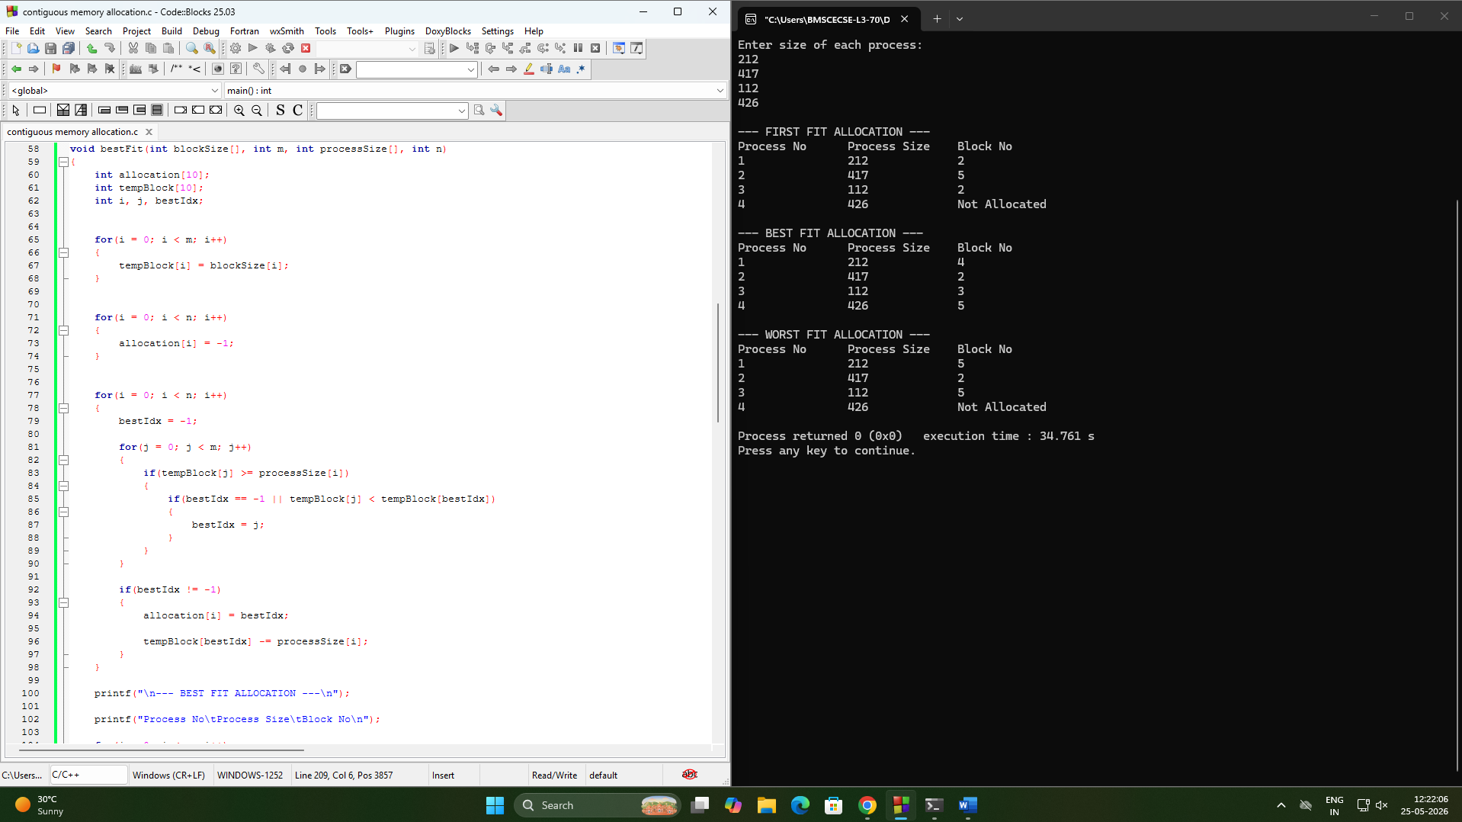

Write a C program to simulate page replacement algorithms.
a) FIFO
b) LRU
c) Optimal

#include <stdio.h>

int frames[10], pages[50], n, f;

void printFrames()
{
int i;

for(i = 0; i < f; i++)
{
if(frames[i] == -1)
printf("- ");
else
printf("%d ", frames[i]);
}

printf("\n");
}

void FIFO()
{
int i, j, k = 0, flag, faults = 0;

for(i = 0; i < f; i++)
frames[i] = -1;

printf("\nFIFO Page Replacement Process:\n");

for(i = 0; i < n; i++)
{
flag = 0;

for(j = 0; j < f; j++)
{
if(frames[j] == pages[i])
{
flag = 1;
break;
}
}

if(flag == 0)
{
frames[k] = pages[i];
k = (k + 1) % f;
faults++;

printf("PF No. %d: ", faults);
printFrames();
}
}

printf("FIFO Page Faults: %d\n", faults);
}

void LRU()
{
int i, j, k, pos, faults = 0;
int time[10], counter = 0, flag;

for(i = 0; i < f; i++)
{
frames[i] = -1;
time[i] = 0;
}

printf("\nLRU Page Replacement Process:\n");

for(i = 0; i < n; i++)
{
flag = 0;

for(j = 0; j < f; j++)
{
if(frames[j] == pages[i])
{
counter++;
time[j] = counter;
flag = 1;
break;
}
}

if(flag == 0)
{
pos = 0;

for(j = 1; j < f; j++)
{
if(time[j] < time[pos])
pos = j;
}

frames[pos] = pages[i];

counter++;
time[pos] = counter;

faults++;

printf("PF No. %d: ", faults);
printFrames();
}
}

printf("LRU Page Faults: %d\n", faults);
}

int predict(int index)
{
int i, j, farthest = index, pos = -1;

for(i = 0; i < f; i++)
{
for(j = index; j < n; j++)
{
if(frames[i] == pages[j])
{
if(j > farthest)
{
farthest = j;
pos = i;
}
break;
}
}

if(j == n)
return i;
}

if(pos == -1)
return 0;
else
return pos;
}

void Optimal()
{
int i, j, pos, faults = 0, flag;

for(i = 0; i < f; i++)
frames[i] = -1;

printf("\nOptimal Page Replacement Process:\n");

for(i = 0; i < n; i++)
{
flag = 0;

for(j = 0; j < f; j++)
{
if(frames[j] == pages[i])
{
flag = 1;
break;
}
}

if(flag == 0)
{

for(j = 0; j < f; j++)
{
if(frames[j] == -1)
{
frames[j] = pages[i];
faults++;

printf("PF No. %d: ", faults);
printFrames();

flag = 1;
break;
}
}

if(flag == 0)
{
pos = predict(i + 1);

frames[pos] = pages[i];

faults++;

printf("PF No. %d: ", faults);
printFrames();
}
}
}

printf("Optimal Page Faults: %d\n", faults);
}

int main()
{
int i;

printf("Enter the number of Frames: ");
scanf("%d", &f);

printf("Enter the length of reference string: ");
scanf("%d", &n);

printf("Enter the reference string: ");

for(i = 0; i < n; i++)
{
scanf("%d", &pages[i]);
}

FIFO();

LRU();

Optimal();

return 0;
}

Output:

